**Digging into Details**

In our *Employee* example, the name of the table is the same as that of the class (EMPOYEE and Employee, respectively). Thus, we did not mention the table name when declaring the @*Entity* annotation. Let’s suppose our table name is *TBL_EMPLOYEE;* then we need to let Hibernate know that by adding a @*Table* annotation too:

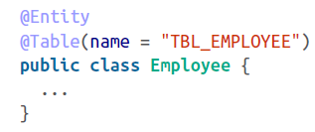

Similarly, as we have already seen in the case of id, if your variable doesn’t match the column name, you must specify the column name using the @*Column* annotation:

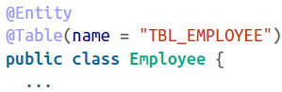

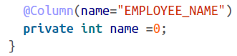

We can also set a few more option for each column using the @*Column* attributes. For example, if the column accepts non-dull data, we fulfill this option by setting *nullable=false.* Or we specify *unique=true* if the column should be generated with a unique constraint. These attributes are shown in the following snippet:

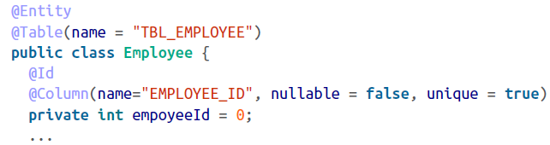

We can set the identifier of each object by employing various strategies. We’ll see this in next section.